Development and Characterization of Textile-Electrode Electroencephalogram Systems for Brain-Computer Interfaces

Daniel Yu
1007678461
January 12th, 2026

Supervisors: Dr. Tom Chau, Dr. Paul Yoo
ECE499Y Thesis | Interim Report

Table of Contents

1.0 Introduction 4
2.0 Literature Review 5
3.0 Progress to Date 7
3.1 Data Collection 7
3.2 Data Analysis 9
3.4 Limitations 14
4.0 Future Work 15
5.0 References 17
6.0 Appendix 19
6.1 Appendix A: Textile Electrode Images 19
6.2 Appendix B: Blink Epoch Data Analysis 20

List of Figures

Figure 1. Three fabric headbands with two textile electrodes of each configuration sewn onto it, totalling 18 total textile electrodes. 8
Figure 2. Raw EEG recording from the 30-45 second window for Electrode 1.1 (raised height of 1 mm). 10
Figure 3. Event related potentials and average amplitude in microvolts for all recorded blinks during the recording of Electrode 1.1 (raised height of 1 mm). 10
Figure 4. Percent difference on the measured microvolts across all nine textile electrodes. 12
Figure 5. Signal-to-noise ratio on across all nine textile electrodes. 13
Figure 6. PSD plot showing higher Alpha band activity during eyes closed experiments on Electrode 1.1 (raised height of 1 mm). 14
Figure 7. PSD plot showing lower Alpha band activity during eyes open experiments on Electrode 1.1 (raised height of 1 mm) 14
Figure 8. Close up of Electrode 1.1. 19
Figure 9. Close up of Electrode 1.2. 19
Figure 10. Close up of Electrode 1.3. 19
Figure 11. Close up of Electrode 2.1. 20
Figure 12. Close up of Electrode 2.2. 20
Figure 13. Close up of Electrode 3.2 20
Figure 14. Close up of Electrode 3.1. 20
Figure 15. Close up of Electrode 3.2. 20
Figure 16. Close up of Electrode 3.3. 20
Figure 17. Detailed blink epoch analysis for Electrode 1.1. 21
Figure 18. Detailed blink epoch analysis for Electrode 1.2. 22
Figure 19. Detailed blink epoch analysis for Electrode 1.3. 23
Figure 20. Detailed blink epoch analysis for Electrode 2.1. 24
Figure 21. Detailed blink epoch analysis for Electrode 2.2. 25
Figure 22. Detailed blink epoch analysis for Electrode 2.3. 26
Figure 23. Detailed blink epoch analysis for Electrode 3.1. 27
Figure 24. Detailed blink epoch analysis for Electrode 3.2. 28
Figure 25. Detailed blink epoch analysis for Electrode 3.3. 29

List of Tables
Table 1. All nine tested textile electrode configurations following the order shown in Figure 1. 8

1.0 Introduction

Electroencephalogram (EEG) systems have become essential tools in both clinical diagnostics and research application, particularly in the field of brain-computer interfaces (BCIs). Conventional EEG systems rely on wet electrodes that require conductive gel to establish electrical contact between the scalp and sensing hardware. While these systems deliver high signal quality suitable for various clinical and research purposes, they present practical limitation as its application of conductive gel is time-consuming, uncomfortable for users, and may cause skin irritation when worn for extended periods. These constraints make traditional wet electrode systems impractical for pediatric population in rehab and long-duration monitoring clinical or research cases.

In recent years, there has been growing interest in developing wearable EEG collection devices that address these usability challenges. Textile-based electrodes have emerged as a promising alternative as its simple integration into fabrics offers improved comfort and flexibility. Unlike wet electrodes, textile electrodes can be incorporated directly into wearable garments or headbands in a dry format without the need for conductive gel. This technological shift has the potential to expand EEG accessibility beyond traditional clinical settings into community and home environments. However, a significant technical challenge persists as textile-based electrodes have not yet proven to achieve signal quality comparable to clinical and research-grade wet electrodes. The primary limitation stems from high impedance at the electrode-skin interface, particularly over hair-covered regions of the scalp where establishing consistent electrical contact is inherently difficult. This impedance mismatch introduces increased noise, reduced signal amplitude, and greater susceptibility to motion artifacts, all of which compromise the reliability of recorded EEG signals. For textile electrodes to become viable alternatives in clinical and BCI applications, these signal quality limitations must be systematically addressed through coordinated advances in both hardware design and signal processing methodologies.

The objective of this thesis is to advance the development of a wearable EEG systems using textile-based electrodes for signal acquisition over both hair-covered regions and areas where skin is directly exposed. By addressing both the pre-amplifier circuit design and digital signal processing techniques, this research aims to maximize the signal-to-noise ratio and classification accuracy of textile-based EEG recordings, ultimately achieving performance comparable to standard clinical systems. The combined hardware-software system developed through this work will be characterized and benchmarked against gold-standard clinical EEG electrodes using both motion artifacts detection and fundamental experimental paradigms (such as eyes-open/eyes-closed protocols). Performance will be evaluated across measurement sites on both hair-covered and bare-skin regions to comprehensively assess the system's practical applicability.

The significance of this research extends beyond immediate technical contributions as demonstrating the feasibility of textile-based EEG for wearable BCI applications addresses a critical gap in pediatric neurotechnology that conventional wet electrode systems cannot. Success in this work would enable more accessible, comfortable, and practical EEG monitoring solutions for children, supporting both clinical care delivery and research participation. Furthermore, the research outcomes are expected to contribute to both academic knowledge through publications and potential commercialization efforts with industry partners. Finally, the findings will support the preparation of manuscripts detailing textile electrode validation, EEG signal pre-amplifier design, and software-based signal filtering techniques, with applications extending toward next-generation wearable BCI systems and expanded clinical use cases in pediatric populations.

2.0 Literature Review

The development of textile-based electrodes for biopotential signal monitoring has emerged as a promising research direction in wearable health monitoring systems. Several groups have conducted comprehensive reviews demonstrating that textile electrodes can achieve acceptable signal quality for various biopotential measurements when properly designed and implemented [1, 2, 3]. Research comparing textile electrodes to standard clinical electrodes has yielded promising but varied results depending on measurement location and electrode design. Liu et al. investigated textile dry contact electrodes during physical activity, finding that correlation between EEG signals from wet and textile electrodes reached 95.6% under motion conditions, demonstrating near-equivalent signal capture capability [4]. However, textile electrodes face particular challenges when measuring over hair-covered regions of the scalp as studies have consistently shown that hair-covered areas present significantly higher impedance, reducing signal quality compared to hairless regions such as the forehead [4, 5].

Additionally, the amplification of biopotential signals presents unique technical challenges that distinguish these systems from general-purpose amplifiers. Biopotential amplifiers must satisfy several critical requirements such as the need for ultra-high input impedance to minimize signal loading, high common-mode rejection ratio (CMRR) to suppress noise, appropriate bandwidth for the signals of interest, sufficient gain to amplify microvolt-level signals, and protection circuits to ensure patient safety [6, 7].

The impedance characteristics of textile electrodes differ substantially from wet electrodes. López-Larraz et al. noted that while standard wet EEG electrodes typically exhibit impedances below 5 kΩ, textile and other dry sensors operate in the range of hundreds of kΩ, resulting in inherently higher noise levels [8]. This fundamental impedance difference necessitates specialized amplifier designs with ultra-high input impedance to prevent signal loading and distortion [6]. Rahman et al. demonstrated that skin impedance should ideally be maintained between 5-20 kΩ for accurate EEG signal generation, though this target becomes challenging to achieve with dry textile electrodes, particularly under dry skin conditions [9].

CMRR is equally critical for EEG amplifier design as it quantifies an amplifier's ability to reject signals common to both inputs while amplifying differential signals. This is an essential capability given that EEG signals, typically measured in microvolts are mixed with larger common-mode interference from sources such as power line coupling and muscle artifacts [10]. High-performance instrumentation amplifiers for biopotential measurement typically achieve CMRR values exceeding 110 dB across the frequency range of interest [11]. The three-amplifier instrumentation amplifier topology has become standard in biopotential applications, providing both high input impedance through buffer amplifiers and excellent CMRR through differential amplification stages [12, 13].

EEG signals span from approximately 0.5 Hz to 100 Hz, with most clinically relevant information contained below 40 Hz [14]. This means that bandwidth and filtering requirements must be carefully matched to the EEG frequency content of interest as limiting bandwidth to this range not only preserves signal fidelity but also optimizes signal-to-noise ratio by rejecting out-of-band interference. Typical implementations include high-pass filters above 0.5 Hz to remove DC offset and electrode polarization effects, and low-pass filters below 100 Hz to prevent aliasing and reduce high-frequency noise [14]. The transition between passband and stopband must be sufficiently gradual to avoid phase distortion that could compromise temporal relationships in the signal.

Altogether, active electrode designs where amplification occurs immediately at the electrode site, have gained prominence in dry electrode EEG systems [6]. This approach offers multiple advantages as the amplified signal is less susceptible to cable motion artifacts, the ultra-high input impedance at the electrode prevents impedance mismatch effects, and the low output impedance of the active electrode drives subsequent amplification stages efficiently [6].

3.0 Progress to Date

Building upon the theoretical foundation establish in the literature review, the initial phase of this work constituted experimental data collection and characterization of textile-based electrode signal quality from September to December 2025. This part of the research aimed to establish baseline performance metrics for various textile electrode design parameter and validate their signal quality against gold-standard clinical EEG systems.

3.1 Data Collection

The experimental protocol was designed to systematically evaluate textile electrode performance across multiple design parameters while maintaining controlled comparison with established dry electrode technology. Nine types of textile electrodes that were sewn onto three fabric headbands were tested with each headband varying across three primary design dimensions described in the Table 1 and shown in the same order in Figure 1. All textile electrodes are approximately 1.0 cm x 1.0 cm if not specified. More detailed images of can be seen in Appendix A.

Table 1. All nine tested textile electrode configurations following the order shown in Figure 1.
Raised Height | Electrode 1.1  1 mm | Electrode 1.2  2 mm | Electrode 1.3  3 mm
Silver Density | Electrode 2.1  Least dense (1.0x) | Electrode 2.2  Moderately dense (1.5x) | Electrode 2.3  Most dense (2.0x)
Area Size | Electrode 3.1  0.5 cm x 0.5 cm | Electrode 3.2  2.0 cm x 2.0 cm | Electrode 3.3  1.0 cm x 1.0 cm

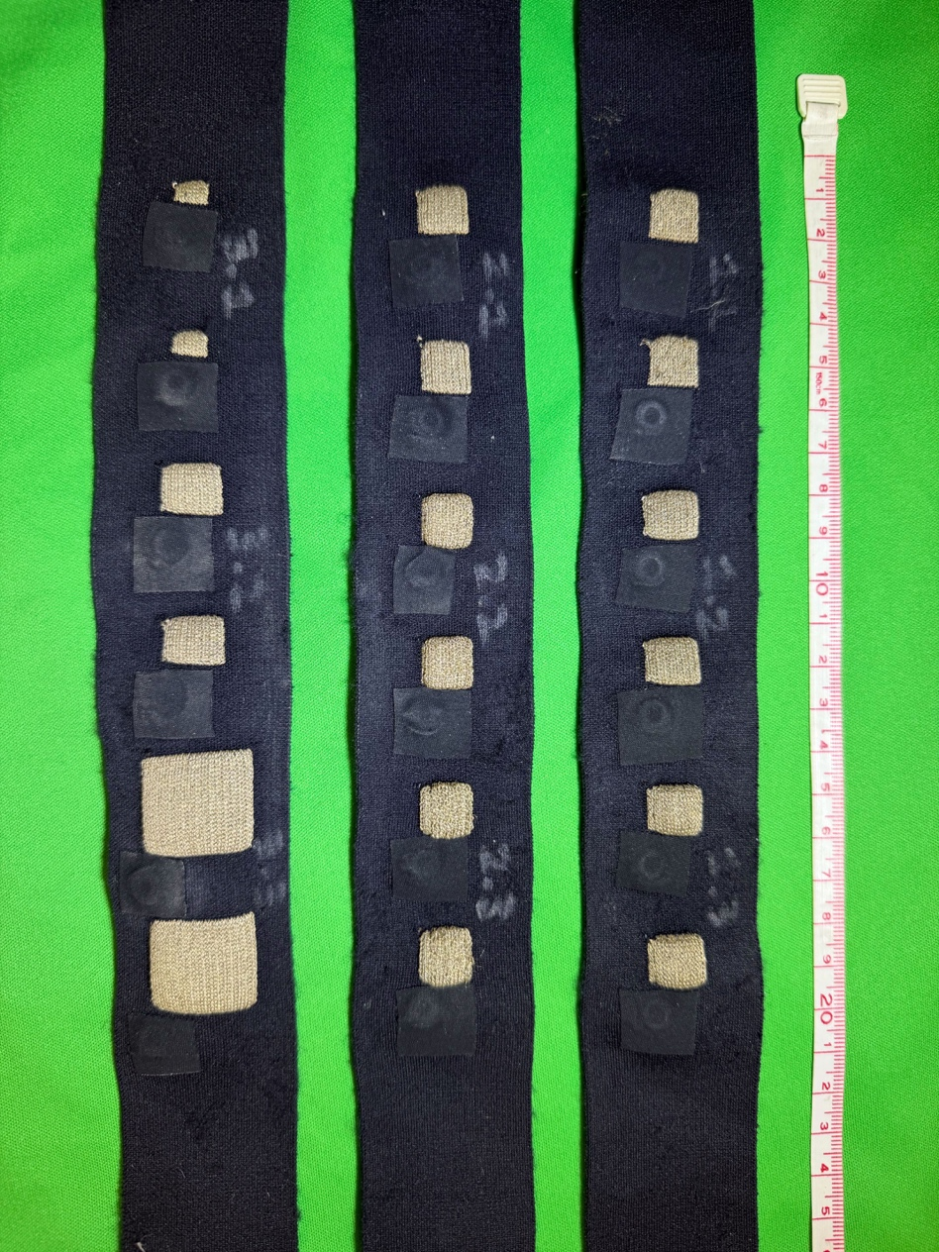
Figure 1. Three fabric headbands with two textile electrodes of each configuration sewn onto it, totalling 18 total textile electrodes.

The data acquisition utilized the BrainProducts LiveAmp system in conjunction with Lab Recorder and Mindset software, enabling synchronized multichannel EEG recording with precise timing control. The experimental setup positioned textile electrodes at Fp1 and the gold-standard clinical BrainProducts electrodes without the use of gel at the Fp2 location according to the international 10-20 system. Both electrodes used the BrainProducts pre-amplifier circuit connected by a snap button with ground and reference electrodes placed beside each other behind the left ear. The forehead placement was strategically chosen as it represents a hairless region with relatively low impedance, allowing initial validation of textile electrode performance under favorable conditions before progressing to more challenging hair-covered sites.

Two complementary experiments were implemented to assess different aspects of electrode performance. The blink test protocol required me to perform deliberate eye blinks at approximately two-second intervals over a 200-second recording session for each of the nine electrode configurations. This test specifically targets motion artifact characterization, as eye blinks generate large-amplitude, artifacts propagating across frontal electrodes. The consistent morphology and timing of blink artifacts provides a quantifiable metric for comparing artifact amplitude, waveform fidelity, and signal-to-noise characteristics between textile and commercial electrodes.

The second experiment was a eyes-open/eyes-closed test that assessed the electrodes' ability to capture physiologically relevant neural oscillations, specifically focusing on alpha band (8-13 Hz) modulation. This protocol required me to alternate between 10-second eyes-open and 10-second eyes-closed recordings, repeated ten times per electrode configuration. Alpha synchronization during eyes closure from a reduced visual processing demand and cortical idling provides a strong benchmark for evaluating electrode sensitivity to frequency-specific neural activity.

3.2 Data Analysis

Preliminary analysis of blink-induced motion artifacts revealed clear, systematic differences between textile and commercial dry EEG electrodes, driven primarily by electrode–skin contact mechanics. Blink artifacts appeared as large, bilaterally symmetric deflections in both Fp1 and Fp2 as seen in Figure 2, often reaching several hundred microvolts, making them a sensitive indicator of contact quality and impedance.

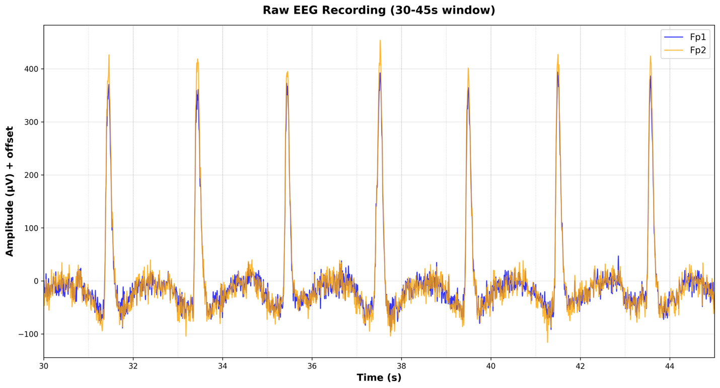
Figure 2. Raw EEG recording from the 30-45 second window for Electrode 1.1 (raised height of 1 mm).

Figure 3 show the exact difference between textile electrodes and the gold-standard ones on event-related potentials across all blinks. This figure shows the performance of Electrode 1.1 (raised height of 1 mm) on the Fp1 position shown in blue compared against the performance of the gold-standard electrode shown in orange at Fp2. At the average peak amplitude, there is approximately an 11.5% percent difference, or around 41.4 µV between their detection peaks on average.

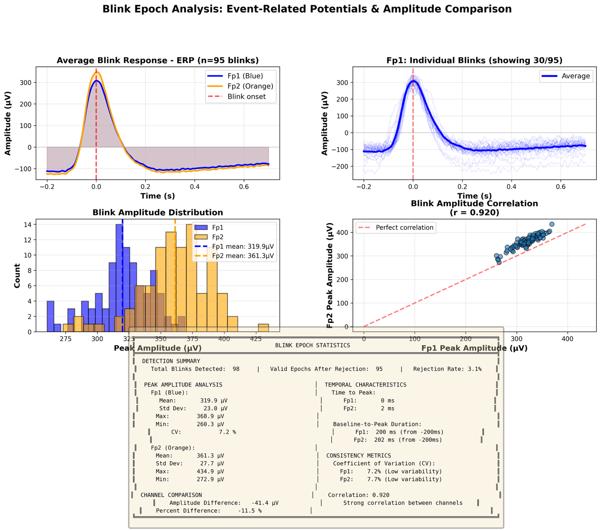
Figure 3. Event related potentials and average amplitude in microvolts for all recorded blinks during the recording of Electrode 1.1 (raised height of 1 mm).

Within the textile designs, electrode height had the strongest effect as 2–3 mm raised electrodes produced artifact amplitudes and temporal profiles closely matching those of the gold-standard dry electrodes, whereas 1 mm electrodes showed attenuated responses, consistent with inadequate contact pressure during facial muscle motion. These observations support the general expectations that increased electrode height improves penetration through superficial skin layers and stabilizes the interface. Higher silver density reduced baseline noise and improved stability between blink events, though its impact on artifact amplitude was weaker than that of height, indicating that mechanical contact dominates artifact formation. Electrode area affected both amplitude and drift: larger areas captured stronger blink artifacts but were more prone to baseline instability, while a 1.0 cm area offered a practical compromise. Full event related potential analysis can be seen in Appendix B.

Overall, this is summarized in Figure 4 as a percent difference of the microvolts detected between the current tested textile electrode and the gold-standard one. Furthermore, the signal-to-noise ratio (SNR) was calculated and summarized in Figure 5, by comparing root mean square of the overall signal strength against the high-frequency noise levels above 30 Hz for each textile electrode, and its results match the percent difference in Figure 4 in a nearly inversely proportional manner.

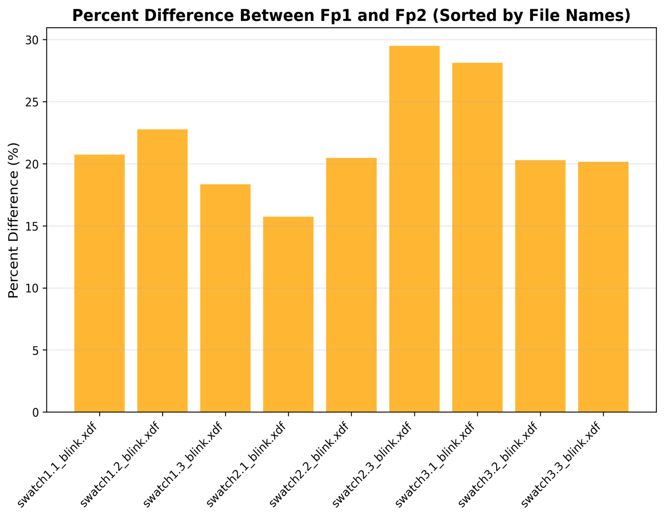
Figure 4. Percent difference on the measured microvolts across all nine textile electrodes.
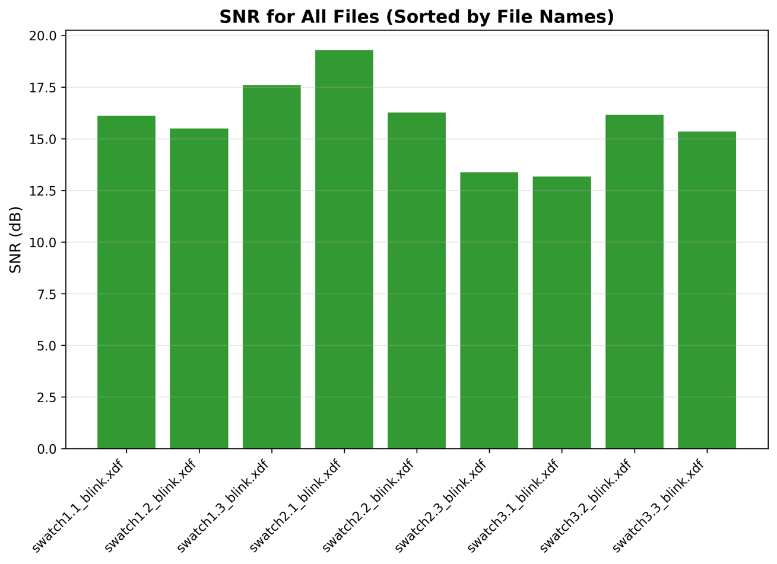
Figure 5. Signal-to-noise ratio on across all nine textile electrodes.

For the eyes-open/eyes-closed experiment, initial power spectral density (PSD) analysis showed that textile electrodes reliably captured physiologically meaningful alpha activity, with increased 8–13 Hz power during eyes-closed conditions across all configurations as seen in comparison of Figure 6 and 7. While textile electrodes reproduced correct alpha peak frequencies and temporal modulation, they exhibited broader spectra, slightly slower transition dynamics, and lower correlations with the gold-standard electrodes, indicating a slightly reduced but still robust fidelity in detecting neural oscillations.
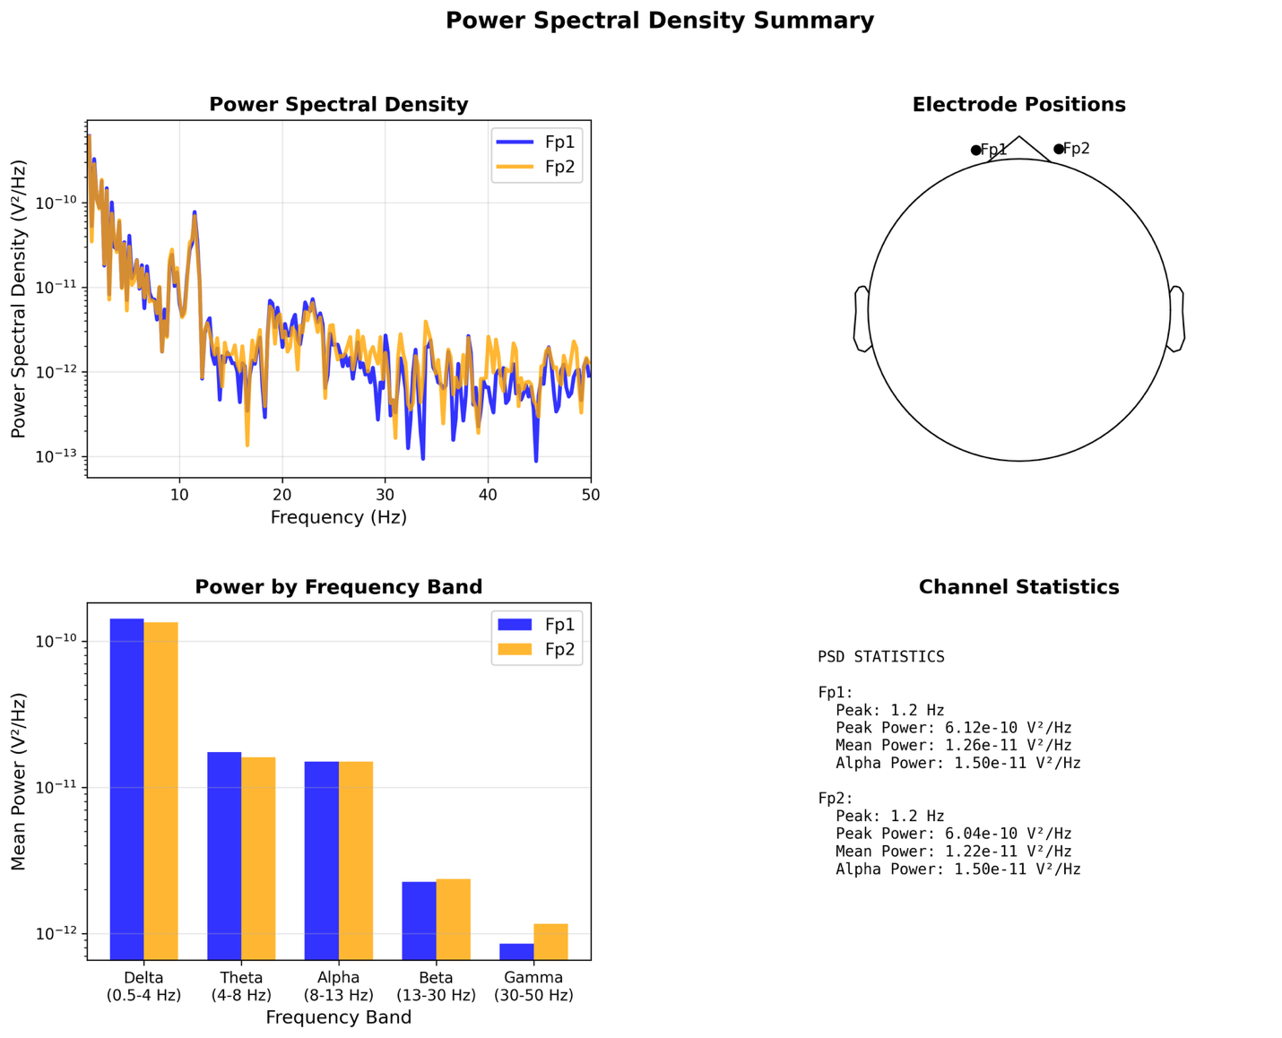  Figure 6. PSD plot showing higher Alpha band activity during eyes closed experiments on Electrode 1.1 (raised height of 1 mm). | 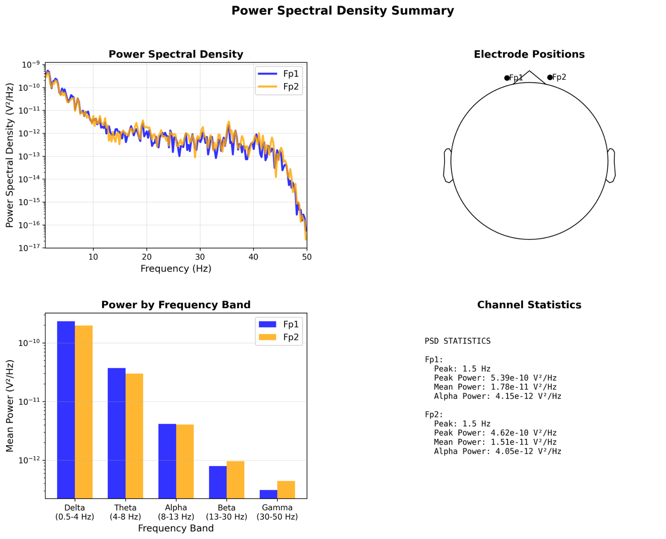  Figure 7. PSD plot showing lower Alpha band activity during eyes open experiments on Electrode 1.1 (raised height of 1 mm)

3.4 Limitations

Several experimental limitations must be acknowledged in the interpretations and characterization of the results. The method in which the textile electrode were attached lacked precise control over contact pressure, as textile electrodes were manually positioned and secured with fabric headbands rather than standardized fixtures. Variations in headband tension across trials likely introduced inconsistencies in electrode-skin contact pressure, potentially contributing to performance variability beyond inherent electrode design differences. This limitation particularly affects interpretation of raised height comparisons, where contact pressure directly influences effective skin penetration depth.

Manufacturing variability in the sewn textile electrode patches represents another source of uncertainty. Minor variations in thread tension, stitch density, and conductive material distribution may result in inconsistencies that partially obscure the different design parameter effects, particularly for the silver density variations where fabric layer alignment critically determines overall conductivity.

Lastly, the high electrode-skin impedance characteristic of textile electrodes can create an impedance mismatch with the LiveAmp amplifier input, potentially causing signal attenuation and increased noise susceptibility. While the LiveAmp system specifies high input impedance suitable for dry electrodes, the extremely high impedance of textile electrodes may approach levels where impedance matching becomes suboptimal. This mismatch represents a fundamental limitation addressable only through dedicated pre-amplifier design with ultra-high input impedance, motivating the next phase of hardware development described in the future work section.

4.0 Future Work

Firstly, the PSD analysis conducted to date has focused on singular comparisons and therefore, a comprehensive analysis and average of all nine textile electrode configurations across the complete frequency spectrum remains to be completed. This systematic PSD analysis will enable detailed quantification of how each design parameter (raised height, silver density, electrode area) influences spectral characteristics across clinically relevant EEG frequency bands including delta (0.5-4 Hz), theta (4-8 Hz), alpha (8-13 Hz), and beta (13-30 Hz). Additionally, future work on the data analysis side includes improving figure presentation by standardizing axis scaling and refining legends and titles for greater clarity and consistency.

The primary focus for the Winter 2026 term centers on designing and prototyping an active electrode pre-amplifier system specifically optimized for textile electrode characteristics. This pre-amplifier will implement a three-stage instrumentation amplifier topology providing ultra-high input impedance, configurable gain, and appropriate frequency filtering. High input impedance will be achieved through bootstrapping techniques and careful selection of ultra-low bias current operational amplifiers.

Configurability represents a key design requirement enabling optimization for different measurement sites and electrode types. Gain will be adjustable through surface-mount device (SMD) resistor selection, allowing tailored amplification for the varying signal amplitudes encountered across scalp locations. Similarly, band-pass filtering characteristics will be configurable via SMD resistors, enabling adjustment of high-pass and low-pass cutoff frequencies to match specific application requirements while maximizing signal-to-noise ratio.
Common-mode noise rejection will be addressed through differential amplifier design with high common-mode rejection ratio and will operate from 3.3-5V supply rails to enable integration with portable battery-powered systems. The output of the pre-amplifier will interface directly with the Texas Instruments ADS1299x family of analog-to-digital converters, which provide 24-bit resolution and integrated programmable gain amplifiers specifically designed for EEG applications.

Component selection and initial circuit simulation are planned for completion by the end of January 2026, followed by a printed circuit board PCB layout and fabrication in early February. Prototype testing against wet electrode reference systems will commence in mid-February, with iterative refinement continuing through March 2026. Initial prototyping will utilize breadboards, and conventional PCBs, however, if time permits, flexible PCB (flex PCB) technology represents a promising future direction for integrating the pre-amplifier directly into textile electrode assemblies. Performance metrics including input impedance, noise floor, and frequency response will be characterized using signal generator validation before proceeding to human subject testing. The integration of an optimized pre-amplifier with textile electrodes and comprehensive benchmarking against clinical-grade systems will constitute the final validation phase, scheduled for mid-March 2026 to allow sufficient time for thesis writing and presentation in early April 2026.

5.0 References

[1] G. Acar et al., “Wearable and flexible textile electrodes for biopotential signal monitoring: A Review,” Electronics, vol. 8, no. 5, p. 479, Apr. 2019. doi:10.3390/electronics8050479

[2] C. M. Vidhya, Y. Maithani, and J. P. Singh, “Recent advances and challenges in textile electrodes for wearable biopotential signal monitoring: A comprehensive review,” Biosensors, vol. 13, no. 7, p. 679, Jun. 2023. doi:10.3390/bios13070679

[3] A. B. Nigusse, D. A. Mengistie, B. Malengier, G. B. Tseghai, and L. V. Langenhove, “Wearable smart textiles for long-term electrocardiography monitoring—a review,” Sensors, vol. 21, no. 12, p. 4174, Jun. 2021. doi:10.3390/s21124174

[4] Q. Liu et al., “The feature, performance, and prospect of advanced electrodes for electroencephalogram,” Biosensors, vol. 13, no. 1, p. 101, Jan. 2023. doi:10.3390/bios13010101

[5] J. Löfhede, F. Seoane, and M. Thordstein, “Textile electrodes for EEG recording — a pilot study,” Sensors, vol. 12, no. 12, pp. 16907–16919, Dec. 2012. doi:10.3390/s121216907

[6] J. Xu, S. Mitra, C. Van Hoof, R. F. Yazicioglu, and K. A. Makinwa, “Active electrodes for wearable EEG acquisition: Review and Electronics Design Methodology,” IEEE Reviews in Biomedical Engineering, vol. 10, pp. 187–198, 2017. doi:10.1109/rbme.2017.2656388

[7] R. R. Harrison and C. Charles, “A low-power low-noise CMOS for amplifier neural recording applications,” IEEE Journal of Solid-State Circuits, vol. 38, no. 6, pp. 958–965, Jun. 2003. doi:10.1109/jssc.2003.811979

[8] E. López-Larraz et al., “A garment that measures brain activity: Proof of concept of an EEG sensor layer fully implemented with Smart Textiles,” Frontiers in Human Neuroscience, vol. 17, May 2023. doi:10.3389/fnhum.2023.1135153
[9] S. M. Rahman, H. Mattila, M. Janka, and J. Virkki, “Impedance evaluation of textile electrodes for EEG measurements,” Textile Research Journal, vol. 93, no. 7–8, pp. 1878–1888, Nov. 2022. doi:10.1177/00405175221135131

[10] M. Chen, J. Wang, D. Anzai, G. Fischer, and J. Kirchner, “Common-mode noise reduction in noncontact biopotential acquisition circuit based on imbalance cancellation of electrode-body impedance,” Sensors, vol. 20, no. 24, p. 7140, Dec. 2020. doi:10.3390/s20247140

[11] Y. M. Chi, C. Maier, and G. Cauwenberghs, “Integrated ultra-high impedance front-end for non-contact biopotential sensing,” 2011 IEEE Biomedical Circuits and Systems Conference (BioCAS), pp. 456–459, Nov. 2011. doi:10.1109/biocas.2011.6107826

[12] M. A. Mayosky and E. M. Spinelli, “AC coupled three op-amp biopotential amplifier with active DC suppression,” IEEE Transactions on Biomedical Engineering, vol. 47, no. 12, pp. 1616–1619, 2000. doi:10.1109/10.887943

[13] R. Pallás-Areny and J. G. Webster, “Composite instrumentation amplifier for biopotentials,” Annals of Biomedical Engineering, vol. 18, no. 3, pp. 251–262, May 1990. doi:10.1007/bf02368441

[14] S. Vanhatalo, J. Voipio, and K. Kaila, “Full-band EEG (FBEEG): An emerging standard in electroencephalography,” Clinical Neurophysiology, vol. 116, no. 1, pp. 1–8, Jan. 2005. doi:10.1016/j.clinph.2004.09.015

6.0 Appendix

The following section provides more detailed images on the progress made in various areas.

6.1 Appendix A: Textile Electrode Images

Figures 8-10 shows the close-ups of all the raised height electrodes.

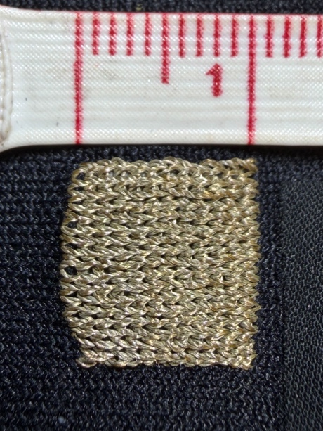  Figure 8. Close up of Electrode 1.1. | 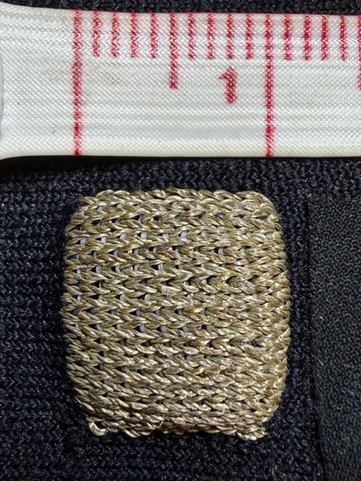  Figure 9. Close up of Electrode 1.2. | 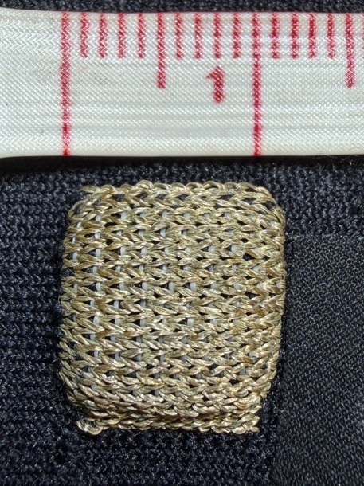  Figure 10. Close up of Electrode 1.3.

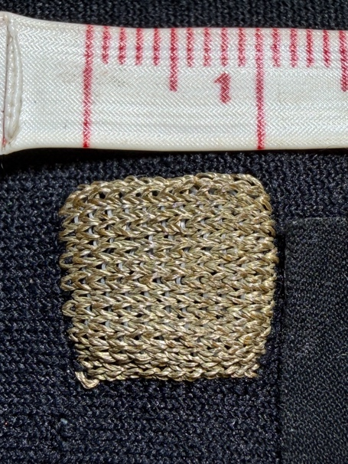  Figure 11. Close up of Electrode 2.1. | 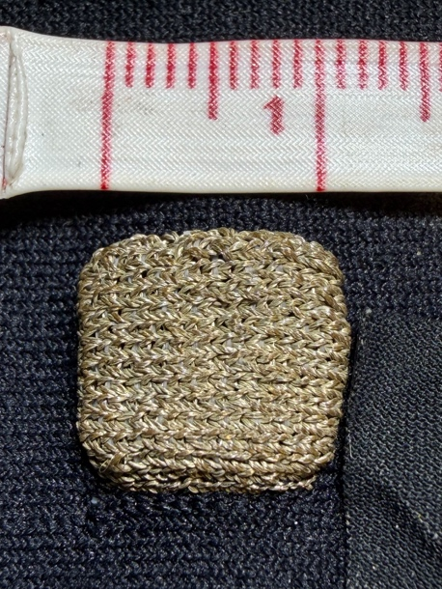  Figure 12. Close up of Electrode 2.2. | 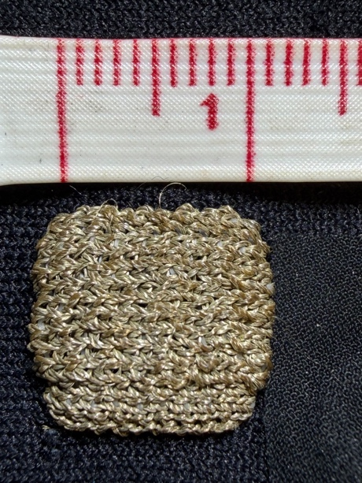  Figure 13. Close up of Electrode 3.2

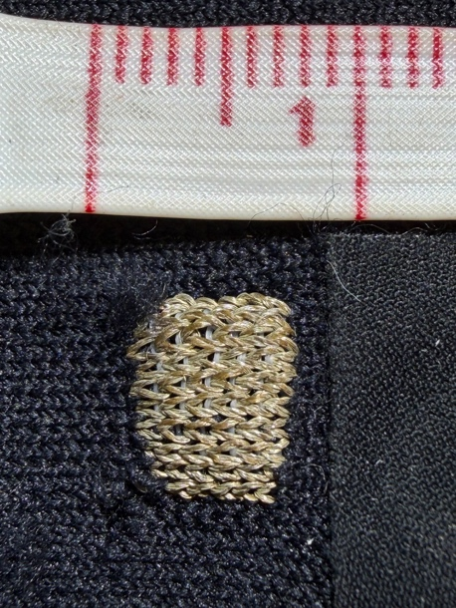  Figure 14. Close up of Electrode 3.1. | 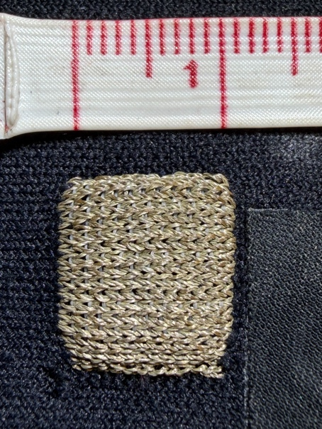  Figure 15. Close up of Electrode 3.2. | 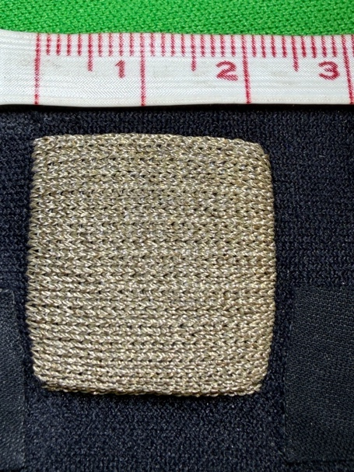  Figure 16. Close up of Electrode 3.3.

6.2 Appendix B: Blink Epoch Data Analysis

Full blink epoch analysis for all nine textile electrodes shown in Figures 17-25.

Figure 17. Detailed blink epoch analysis for Electrode 1.1.

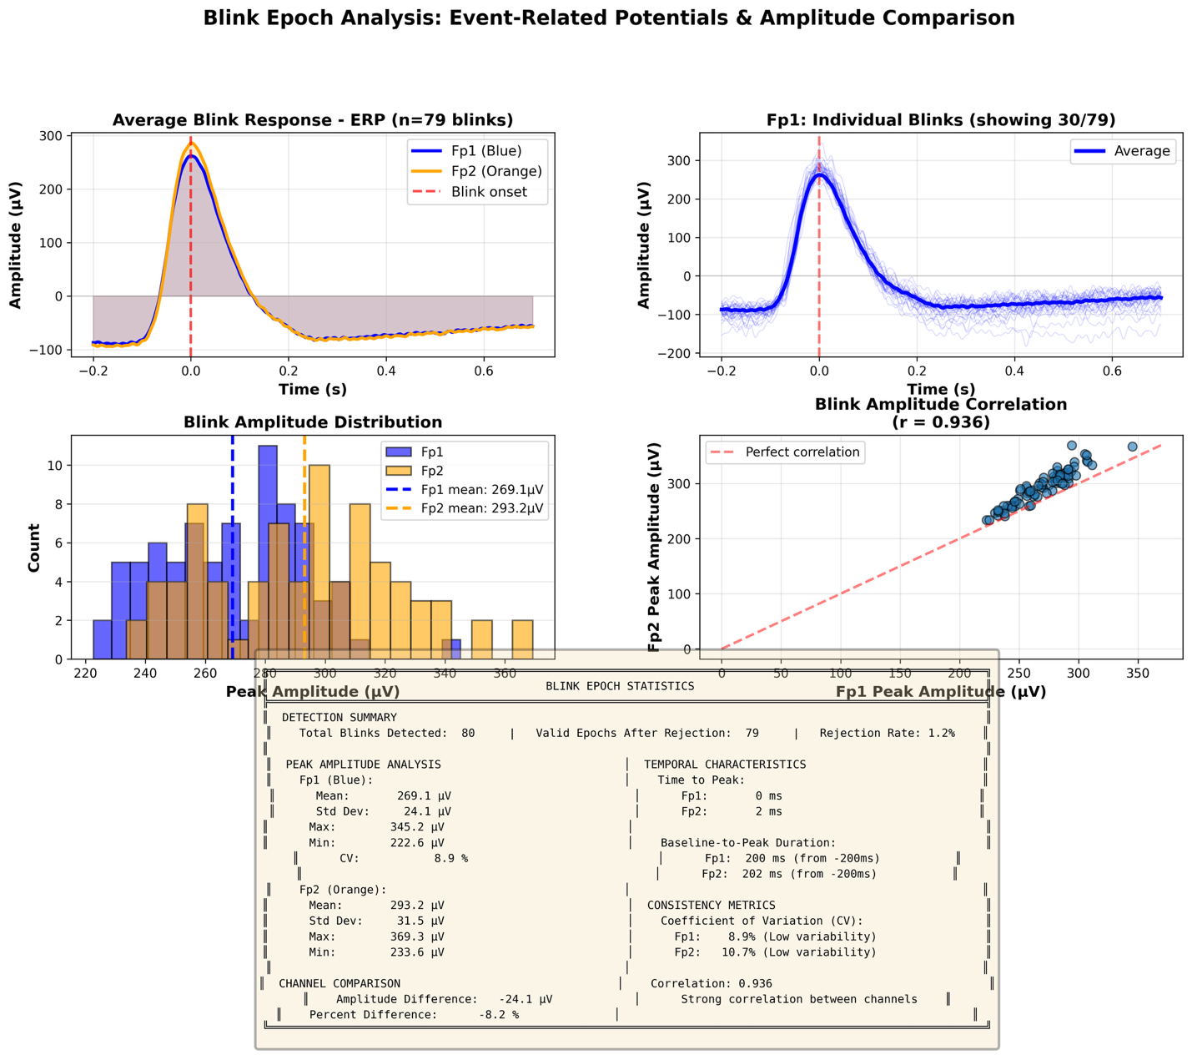
Figure 18. Detailed blink epoch analysis for Electrode 1.2.

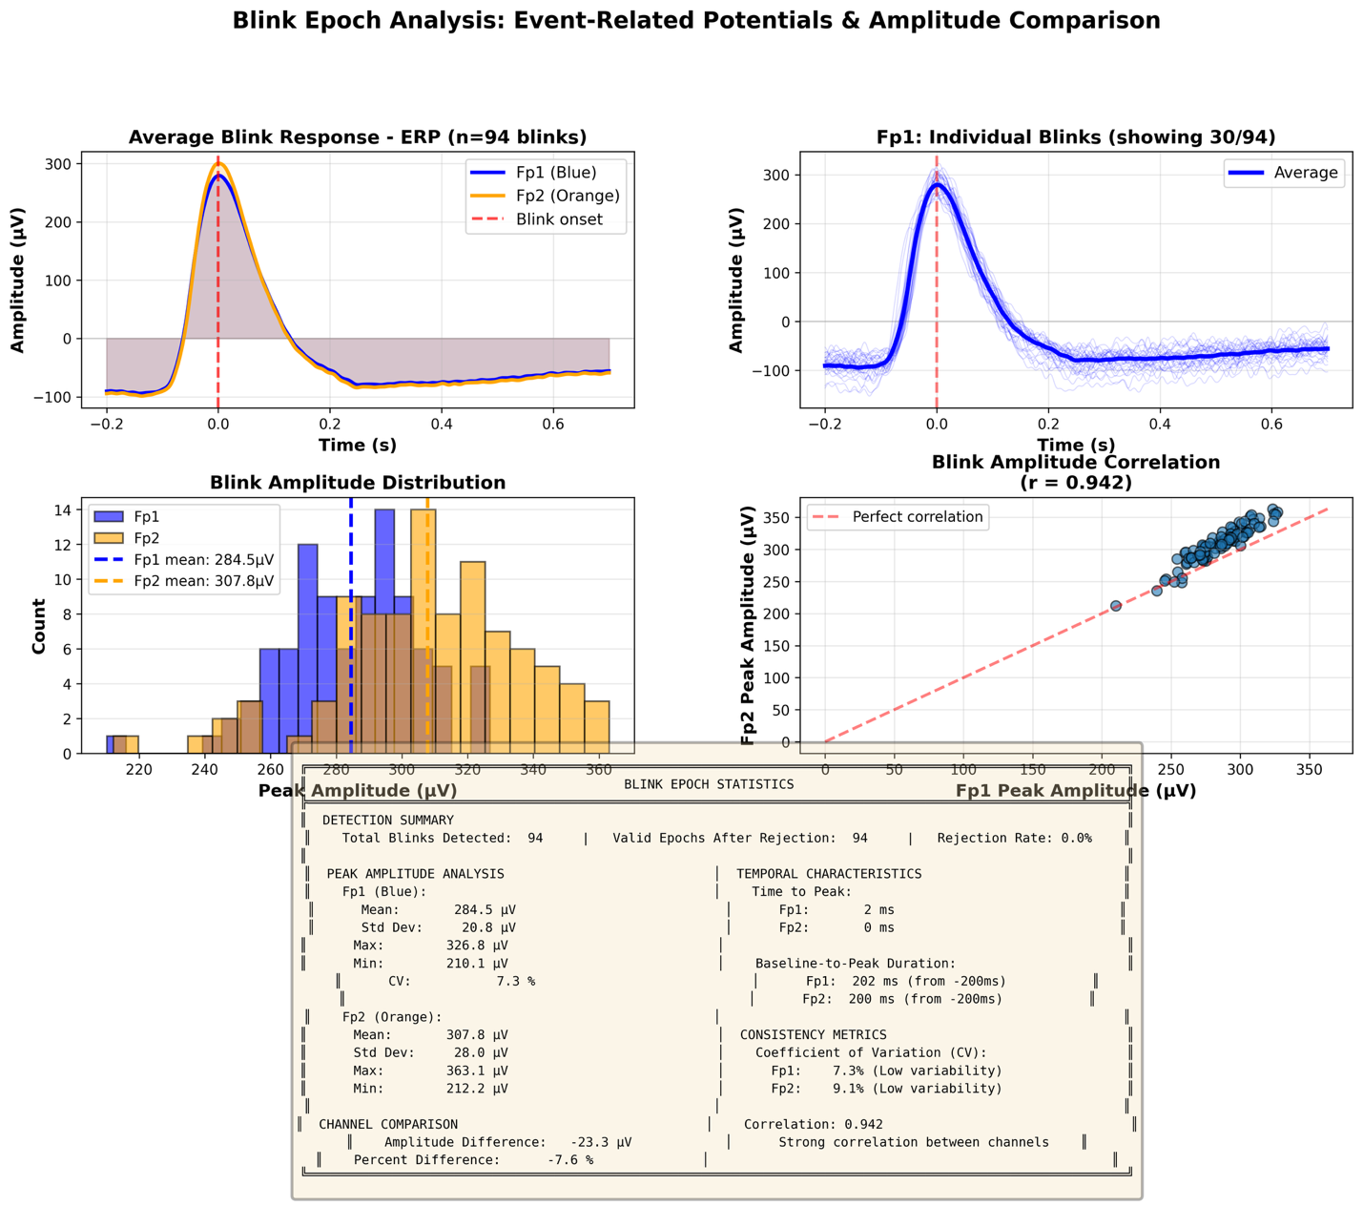
Figure 19. Detailed blink epoch analysis for Electrode 1.3.

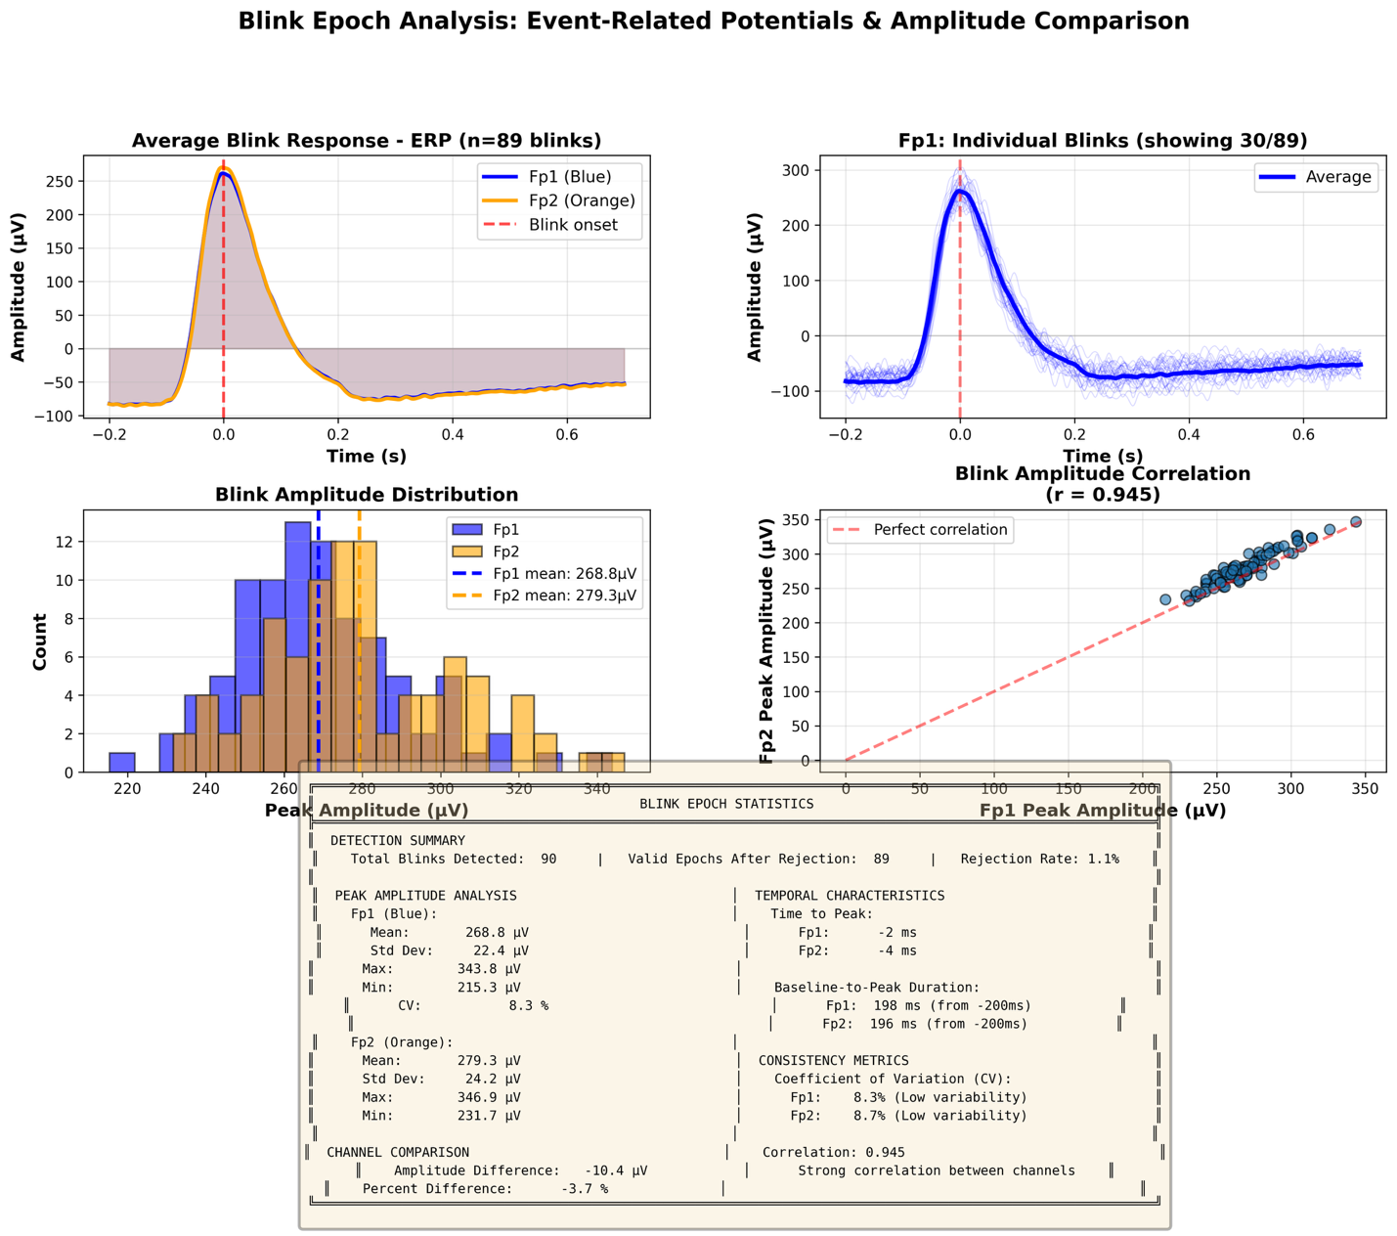
Figure 20. Detailed blink epoch analysis for Electrode 2.1.

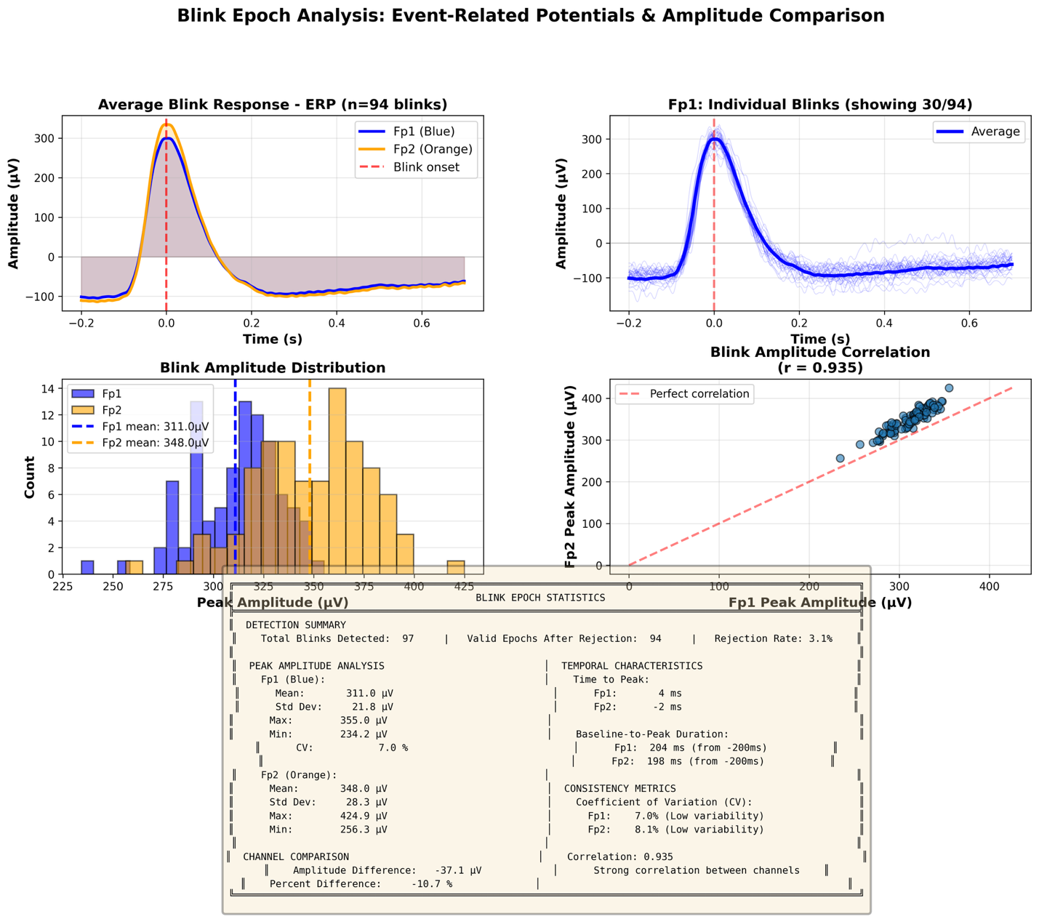
Figure 21. Detailed blink epoch analysis for Electrode 2.2.

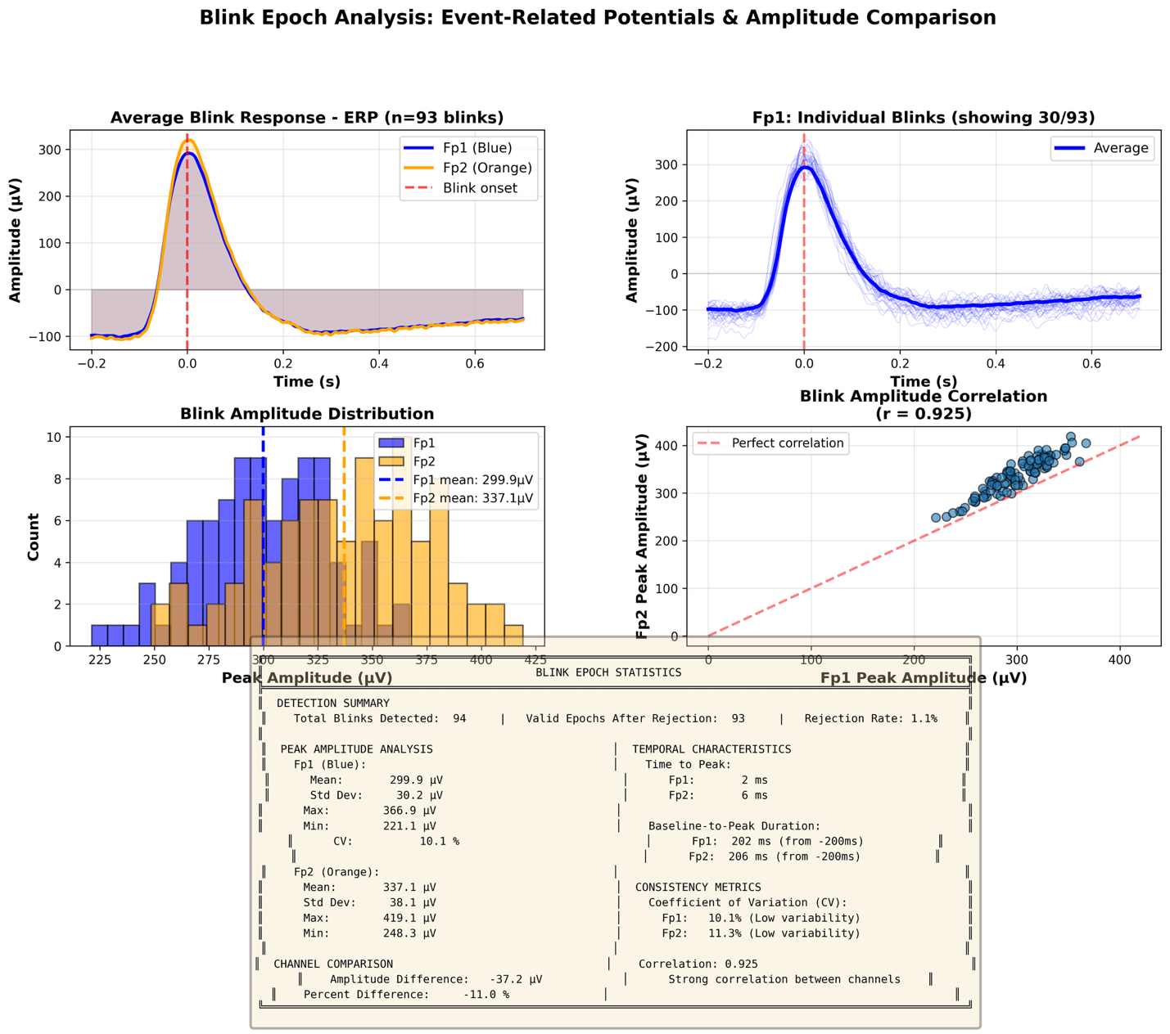
Figure 22. Detailed blink epoch analysis for Electrode 2.3.

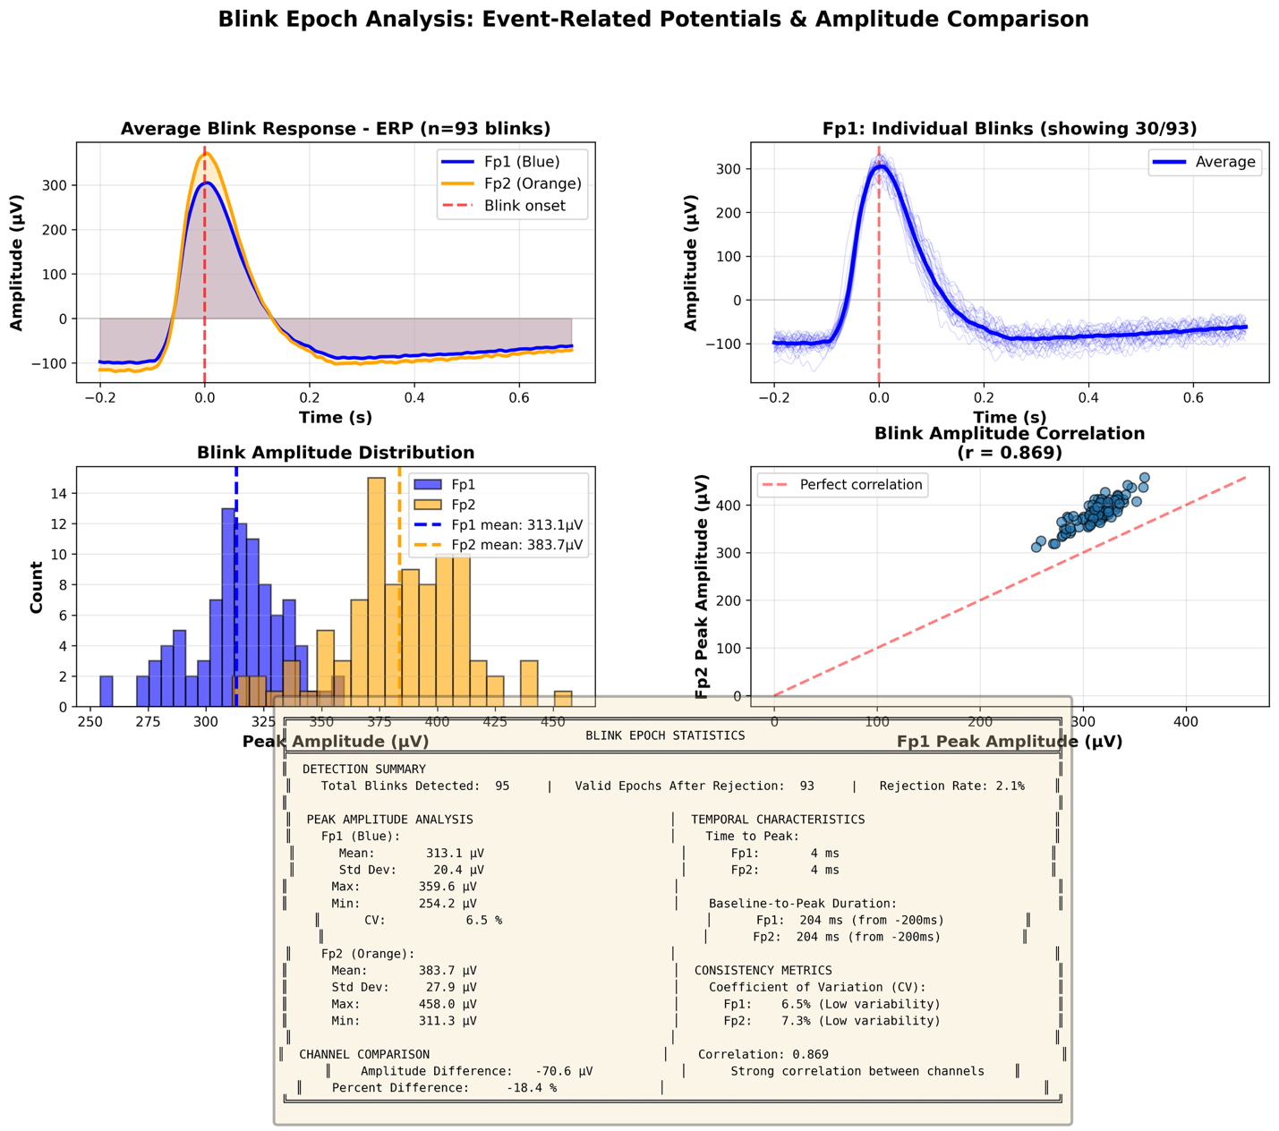
Figure 23. Detailed blink epoch analysis for Electrode 3.1.

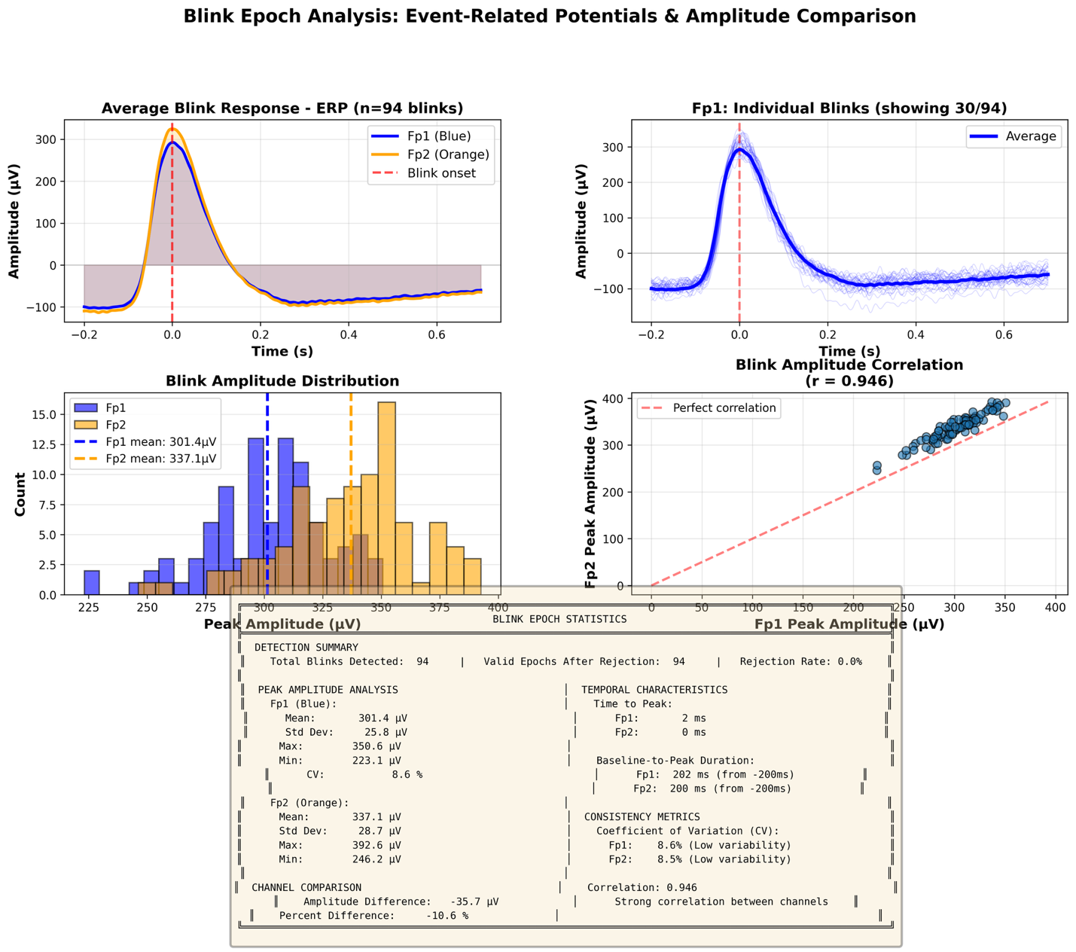
Figure 24. Detailed blink epoch analysis for Electrode 3.2.

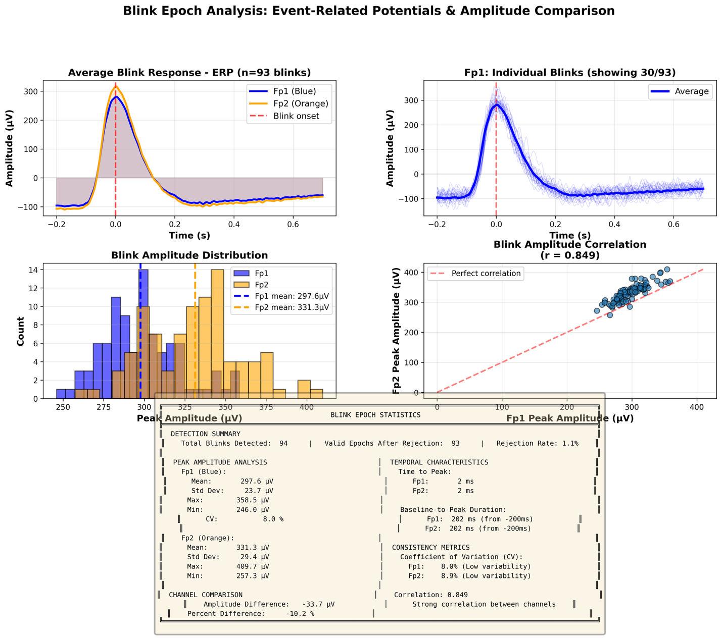
Figure 25. Detailed blink epoch analysis for Electrode 3.3.

